

|  |  |
| --- | --- |
| **GH-1640ZK** | METAL LATHE |

**321850T**

**400/50/3**

# PARTS LIST

**Walter Meier (Tool) AG**

Tämperlistrasse 5

CH-8117 Fällanden

Switzerland

Phone +41 44 806 47 48

Fax +41 44 806 47 58

[jetinfo.eu@waltermeier.com](mailto:jetinfo.eu@waltermeier.com)

[www.jettools.com](http://www.jettools.com)

M-321850T 2012-08

# Table of Contents

Table of Contents 2

Stand Assembly 3

Stand Assembly – Parts List 4

Brake Assembly 5

Brake Assembly – Parts List 6

Bed Assembly 7

Bed Assembly – Parts List 8

Headstock Assembly I 10

Headstock Assembly I – Parts List 11

Headstock Assembly II 12

Headstock Assembly II – Parts List 13

Headstock Assembly III 15

Headstock Assembly III – Parts List 16

Headstock Assembly IV 17

Headstock Assembly IV – Parts List 18

Change Gear Box Assembly I 19

Change Gear Box Assembly I – Parts List 20

Change Gear Box Assembly II 21

Change Gear Box Assembly II – Parts List 22

Quick Change Gear Box I 23

Quick Change Gear Box I – Parts List 24

Quick Change Gear Box II 26

Quick Change Gear Box II – Parts List 27

Quick Change Gear Box III 28

Quick Change Gear Box III – Parts List 29

Apron Assembly I 30

Apron Assembly I – Parts List 31

Apron Assembly II 33

Apron Assembly II – Parts List 34

Apron Assembly III (Threading Dial) 36

Apron Assembly III (Threading Dial) – Parts List 37

Saddle and Cross Slide Assembly 38

Saddle and Cross Slide Assembly – Parts List 39

Tool Post and Compound Rest 41

Tool Post and Compound Rest – Parts List 42

Tailstock Assembly I 43

Tailstock Assembly I – Parts List 44

Tailstock Assembly II 45

Tailstock Assembly II – Parts List 46

Steady Rest Assembly 47

Steady Rest Assembly – Parts List 48

Follow Rest Assembly 49

Follow Rest Assembly – Parts List 50

Coolant and Work Light Assembly 51

Coolant and Work Light Assembly – Parts List 52

Toolbox, Accessories, and Attachments 53

Electrical Components – Parts List 54

Electrical Diagram 55

Rotary Switch Diagram 56

Safety Guard Cover 57

Stand Assembly



Stand Assembly – Parts List

Index No. Part No. Description Size Qty

1 C6136-01734 Cover 1

2 TS-1534032 Cross Head Screw M6x8 16

3 GB1096 Key 1

4 C6136-01101 Pulley 1

5 GB72-8x12 Cylindrical End Set Screw M8x12 1

6 ZK-S06 Main Motor 1

7 C6136ZK-01102A Big Stand 1

8 TS-1550071 Flat Washer 10 mm 4

9 TS-2361101 Lock Washer 10 mm 4

10 GB30 Hex Cap Bolt M10x45 4

11 C6136-01702 Shaft 1

12 GB72-8x25 Cylindrical End Set Screw M8x25 1

13 C6136-01112 Motor Mounting Plate 1

14 GB894 C-Clip 22 mm 2

15 C6136-01701 Shaft 1

16 C6136-01712 Bolt 1

17 TS-2311161 Hex Nut M16 2

18 C6136-01714 Shaft 1

19 C6140ZK-01726J Cover 1

20 C6140ZK-01721B Oil Pan 1

21 C6140ZK-01725J Cover 1

22 C6136-18701-40 Wire Conduit 1

23 TS-1534042 Slotted Pan Head Screw M6x12 1

24 C6136-01724 Locking Plate 1

25 TS-1505041 Hex Socket Cap Screw M8x20 2

26 C6136-01114 Pump Support 1

27 TS-1515021 Countersunk Head Screw M8x20 2

28 C6136-01723A Support 1

29 C6136ZK-01103J Small Stand 1

30 C6140ZK-01717J Cover 1

31 C6136ZK-01722B Front Cover 1

32 TS-1503041 Hex Socket Cap Screw M6x16 8

38 G38-3A Drain Plug Z1/4 2

39 ZKS39 Coolant Level Indicator 1

40 GB97.2-M16 Washer M16 1

Brake Assembly



Brake Assembly – Parts List

Index No. Part No. Description Size Qty

1 ZX-22101 Fork 1

2 ZX-S41 Spring Pin 5x40 mm 1

3 TS-1540061 Hex Nut M8 4

4 ZX-22707A Butt Rod Support 2

5 TS-149006 Hex Cap Screw M8x35 1

6 ZX-22703 Butt Nail Support 1

7 TS-1524021 Hex Set Screw M8x10 1

8 ZX-S73 C-Clip 12 mm 2

9 TS-1490091 Hex Cap Screw M8x50 1

10 ZX-S67 Screw M4x25 2

11 ZK-S11 Stroke Switch 1

12 ZX-22711 Butt Nail Support 1

13 ZX-22704A Driving Shaft – Longer 1

15 ZX-S48 Spring Pin 5x30 mm 2

16 C6136ZK-22712B Pedal 1

17 ZX-22706 Connecting Shaft 1

18 ZX-22715 Adjust Bolt 1

19 ZX-S70 Pin 5n6x20 1

20 C6136ZK-22710B Draw Bar 1

21 ZX-S53 Tensile Spring 3.5x26x190 mm 1

22 ZX-S54 Eyebolt M8 1

23 ZX-S59 C –Clip 8 mm 1

24 ZK-S24 Brake Shoe 1

25 ZX-22701 Positioning Shaft 1

26 ZX-S68 Cylindrical End Set Screw M5x10 1

27 ZX-22702 Brake Shaft 1

28 ZX-22708 Connecting Plate 1

29 ZX-S64 Straight Pin 5x25 mm 1

30 ZX-22709 Connecting Shaft 1

31 ZX-S52 Split Pin 2x20 mm 1

Bed Assembly



Bed Assembly – Parts List

Index No. Part No. Description Size Qty

1 C6136ZK-01104E Bed 1

2 GB67 Washer B16 8

3 GB21 Hex Cap Bolt M16x45 8

4 C6136-01706A Rack 1

5 TS-1505051 Hex Socket Cap Screw M10x35 10

6 GB117-8x45 Taper Pin 8x45 mm 10

7 C6136-01706B Rack (for 1000/40” models) 4

8 C6236ZK-01112 Gap 1

9 GB5782 Hex Cap Bolt M10x55 2

10 TS-1550071 Washer 10 mm 2

11 TS-1492031 Hex Socket Cap Screw M12x35 4

12 GB118-12x55 Threaded Taper Pin 12x55 mm 2

13 TS-2360121 Washer 12 mm 4

18 TS-1505071 Hex Socket Cap Screw M10x45 2

19 TNMP-05741 Threaded Tube 2

20 TS-1540081 Hex Nut M12 2

21 TS-1550041 Washer M6 5

22 TS-1503021 Hex Socket Cap Screw M6x10 5

23 C6140ZK-12701B Splash Guard 1

24 ZX-B18 Shear Pin M5x35 2

25 1440R-01722D Lead Screw 1

26 ZX-B20 Flat End Set Screw M6x10 2

27 C6236-01109 Sleeve 1

28 ZX-1204 Double Row Spherical Bearing 20x47x14 mm 2

29 ZX-B23 C-Clip 20 mm 2

30 ZX01707A Control Rod(for 40” models) 1

31 ZX01110N New Bracket 1

32 ZX01111 Cover 1

33 TS1514021 Hex Socket Cap Screw M6x14 4

34 ZXB31 Taper Pin 6x100 1

35 TS223991 Hex Socket Cap Screw M10x100 1

36 TS1516061 Hex Socket Cap Screw M10x50 1

37 ZXB29 Oil Cup 10 2

38 1440R-01721A Feed Rod (for 40” models) 1

39 C6136-01108 Sleeve 1

40 ZXB27 Taper Pin 6x60 1

43 GB97.2 Washer M5 5

44 GB2672 Hex Socket Asterisk Pan Head Screw M5x8 5

45 ZX-18717 Line Groove 1

46 ZX-06702 Sliding Key 1

47 ZX-06001C-3 Sleeve 1

48 ZX-06001C-2 Spacer 1

49 ZX-B41 Spring 1x75x25 mm 3

50 ZX-06001C-1 Bracket 1

51 TS-1504031 Hex Socket Cap Screw M8x16 2

52 ZX-B49 Taper Pin 8n6x20 mm 1

53 TS-1540061 Hex Nut M8 2

54 ZX-B47 Set Screw M8x28 2

55 ZX-06001C-5 Direction Change Ring 1

56 ZX-B57 Pin 3x16 mm 1

57 ZX-B44 Lever 1

58 ZX-06001C-4 Long Sleeve 1

59 GB878-12x50 Taper Pin 12x50 mm 1

66 C6136-01715 Cover 1

67 ZX-B60 Cross Head Screw M6x18 4

70 C6136-01705 Pin 1

71 C6136-01105 Stoper 1

72 C6136-01106 Clamping Plate 1

73 GB21 Hex Cap Bolt M12x25 2

90 C0632A01301E Switch Box 1

91 ZXB91E Hex Socket Cap Screw M8x20 2

92 ZXB92E Screw M6x16 1

93 CO632A01705E Bushing 1

94 ZXB94E Steel Ball 6 1

95 ZXB95E Spring 1

96 ZXB96E Screw M8x16 1

97 CO632A01504E Switch Box Cover 1

98 ZXB98E Hex Socket Cap Screw M5x10 4

99 CO632A01503E Plug 2

100 ZX01706E Positioning Sleeve 1

101 ZXB101E Screw M5x8 1

104 SQ2，SQ3 Stroke Switch LXW5-11D1 2

Headstock Assembly I



**Headstock Assembly I – Parts List**

Index No. Part No. Description Size Qty

1 C6136ZK-02304 Round Sign Plate 3

2 ZX-H3 Flat End Set Screw M10x12 3

3 ZX-H4 Spring YI-1x8x25 1

4 SB-8MM Steel Ball 8 mm 3

5 C6136ZK-02122 Positioning Handle 1

6 ZX-H6 Countersunk Head Screw M5x12 6

7 ZX-02743 Positioning Disc 1

8 C6136ZK-02742 Shaft 1

9 GB117-5x55 Taper Pin 5x55 mm 1

10 G51-2A Ring Seal 20x2.4 mm 1

11 C6136-02123 Crank 1

12 GB117-4x30 Taper Pin 4x30 mm 1

13 C6136-02738 Pin Block 2

14 Q81-1 Spring YI-1x7x25 2

15 C6136-02119 Left Lever Support 2

16 C6136-02737 Pin Block 2

17 GB117-5x70 Taper Pin 5x70 mm 2

18 C6136-02739 Left Positioning Disc 1

19 ZX-H11 Ring Seal 25x2.4 mm 3

20 C6136ZK-02741 Shaft 1

21 C6136-02118 Crank 1

22 TS-1540031 Hex Nut M5 2

23 GB881 Threaded Tail Taper Pin 5x25 mm 2

24 C6136-02740 Left Positioning Disc 1

25 C6136-02126 Crank 1

26 GB73-02733 Countersunk Head Screw M8x10 4

27 C6136-02115 Bearing Support 2

28 ZX-H64 Ring Seal 40x3.1 1

29 C6136-02120A/1 Left Fork 1

30 C6136-02120A/2 Bushing 1

31 ZX-H66 Flat End Set Screw M6x10 1

32 ZX-H68 Taper Pin 6x35 mm 1

33 C6136-02735 Control Shaft 1

34 C6136-02121 Right Fork 1

35 C6136-02116 Block Piece 1

36 C6140ZK-02305J-2 Headstock Label Plate 1

37 TS-1531012 Cross Recessed Pan Head Screw M3x6 8

38 GB5782-16x45 Hex Cap Bolt M16x45 1

39 GB97-A16 Washer A16 4

40 GB65-6x8 Slotted Cheese Head Screw M6x8 6

41 C6132B-02701 Oil Tray 1

42 C6132B-02702 Oil Tray 1

43 ZX-H85 Hex Socket Cap Screw M16x50 1

44 ZX-H77 Taper Pin 8x40 mm 2

45 ZX-02744 Adjusting Screw 1

46 ZX-H80 Hex Cap Bolt M12x50 1

47 C6136-02124 Adjusting Block 1

48 R51-2 Oil Sight Glass 20 mm 1

49 RE51-2 Crank 1

50 ZX-H85 Hex Cap Bolt M16x50 2

51 C6132B-02703 Oil Tray 1

52 C6136ZK-02508 Paper Gasket 1

53 C6136ZK-02511 Top Cover 1

54 C6136ZK-02512 Rubber Mat 1

55 C6136-02755 Countersunk Head Screw 1

56 TS-1504051 Hex Socket Cap Screw M8x25 8

Headstock Assembly II



Headstock Assembly II – Parts List

Index No. Part No. Description Size Qty

57 GB78-8x16 Set Screw M8x16 2

58 ZK-02743 Round Clamp Nut 1

59 ZX-H60B V-Belt 4

60 C6136ZK-02107 Pulley 1

61 GB70-6x22 Hex Socket Cap Screw M6x22 4

62 ZX-02106A Bearing Cover 1

63 ZX-02506 Gasket 1

64 BB-6207/P6 Ball Bearing 35x72x17 mm 2

65 TS-1504041 Hex Socket Cap Screw M8x20 6

66 C6136ZK-02105 Bearing Support 1

67 ZX-02502 Gasket 1

68 ZX-H106 Flat Key 10x8x35 mm 2

69 C6136ZK-02717 Shaft 1

70 ZK-570 Sleeve 30x16 mm 1

71 C6136-02716 Gear 2.5m49T 1

72 ZK-572 Sleeve 30x25 mm 1

73 C6136-02715 Gear 2.5m49T 1

74 C6136-02714 Sleeve 2.5m42T 1

75 ZK-575 Sleeve 30x8 mm 1

76 BB-6305 Bearing 25x62x17 3

77 ZX-H114 Shaft End Lock Ring 32 mm 1

78 ZX-H115 Countersunk Head Screw M6x20 1

79 ZX-H59 Pin 3n6x10 2

80 ZX-H117 Ring Seal 60x3.1 2

81 ZX-02104 Blocking Flange 1

82 GB73-8x12 Flat End Set Screw M8x12 6

83 TS-1540081 Hex Nut M12 1

84 ZX-H150 Set Screw M12x65 1

85 TS-1503041 Hex Socket Cap Screw M6x16 3

86 C6136-02109 Cover 1

87 C6136-02503 Gasket 1

88 ZX-H147 Pushing Disc 62 mm 1

89 ZX-H133 C-Clip 35 mm 1

90 C6136-02713 Gear 2.5m34T 1

91 GB1096-10x8x40 Flat Key 10x8x40 2

92 GB119-8x30 Pin 8x30 mm 2

93 C6136-02712 Gear 2.5m64T 1

94 C6136-02711 Gear 2.5m41T 1

95 GB894.1 C-Clip 40 mm 2

96 BB-6208/P6 Ball Bearing 40x80x18 1

97 C6136-02718 Shaft 1

98 C6136-02709 Gear 3m52T 1

99 GB1096-8x7x28 Flat Key 8x7x28 mm 2

100 C6136-02710 Gear 2.5m18T 1

101 C6136-02103 Blocking Flange 1

102 ZX-H187 Ring Seal 35x3.1 1

103 GB73-6x8 Flat End Set Screw M6x8 6

104 C6136-02732 Shaft 1

105 C6136-02731 Double Gear 2m38T 1

106 ZX-02303 Copper Sleeve 1

107 C6236-02757 Positioning Sleeve 1

108 GB78-8x16 Set Screw M8x16 2

109 C6136-02733 Blocking Piece 1

110 ZX-H211 Countersunk Head Screw M5x16 1

111 C6136-02724 Washer 1

112 C6140ZK-08706TJ Gear 3.5m15T 1

113 ZX-02301 Bushing 2

114 1440R-08106 Bracket 1

115 ZX-H77 Taper Pin 8x40 mm 1

116 S-1505031 Hex Socket Cap Screw M10x25 1

119 C6136-02722 Sleeve 1

120 ZX-H198 C-Clip 28 mm 2

121 GB1096-5x12 Flat Key 5x12 mm 1

122 C6140ZK-02729 Shaft 1

123 C6136-02303 Gear 2m48T 1

124 BB-6203 Ball Bearing 17x40x12 1

125 C6136-02114 Sleeve 1

Headstock Assembly III



Headstock Assembly III – Parts List

Index No. Part No. Description Size Qty

2 GB77-10x12 Flat End Set Screw M10x12 3

126 C6236-02755/2 Locking Block 1

127 C6236-02755/1 Round Nut 1

128 C6236-02111F Bearing Back Cover 1

129 C6136-02504 Gasket 1

130 C6236-02721 Sleeve 1

131 BB-32013/P5 Taper Roller Bearing 65x100x22 1

132 C6236B-02110 Bearing Support 1

133 TS-1490051 Hex Cap Screw M8x30 6

134 51213/P5 Thrust Bearing 65x100x27 1

135 C6236-02720 Gear 2m48T 1

136 C6236-02756/2 Locking Block 1

137 C6236-02756/1 Round Nut 1

138 C6236-02701 Gear 3m33T 1

139 C6236-02702 Gear 3m67T 1

140 C6236-02754/2 Locking Block 1

141 C6236-02754/1 Round Nut 1

143 GB893 Lining 130 mm 1

144 D3182117 Taper Roller Bearing 85x130x34 1

145 C6236-02704 Oil Splash Ring 1

146 C6236-02501 Gasket 1

147 C6140ZK-02102 Bearing Front Cover 1

148 TS-1504061 Hex Socket Cap Screw M8x30 1

149 C6236-02102 Spindle 1

150 ZX-H154 Flat Key 10x8x50 mm 1

151 GB1096-12x8x55 Flat Key 12x8x55 mm 1

152 C6236-02752 Cam Lock 6

153 ZK-6153 Spring 1x8x22 mm 6

154 G52-1 Copper Washer 17 mm 1

155 G38-2 Drain Plug M16x1.5 1

156 C6236-02753 Cam Positioning Screw 6

157 C6140ZK-02101 Headstock Casting 1

Headstock Assembly IV



Headstock Assembly IV – Parts List

Index No. Part No. Description Size Qty

64 TS-1503011 Hex Socket Cap Screw M6x8 4

65 TS-1504021 Hex Socket Cap Screw M8x12 4

85 TS-1503041 Hex Socket Cap Screw M6x16 8

158 C6140ZK-02729 Cover 1

159 C6140ZK-02728 Back Cover 1

160 TS-1502031 Hex Socket Cap Screw M5x12 3

161 ZX-08712 Upper Hinge 2

162 ZX-H223 Pin 6n6x40 2

163 ZX-08711 Lower Hinge 2

165 CDL400-02705 Rear Side Plate 1

166 C6140ZK-02726 Front Side Plate 1

Change Gear Box Assembly I



Change Gear Box Assembly I – Parts List

Index No. Part No. Description Size Qty

1 ZX-08101 Change Gear Box Casting 1

2 C6140ZK-08108J Front Cover 1

3 C6140ZK-08703 Splash Guard 1

4 GB818-M5x12 Cross Recessed Pen Head Screw M5x12 3

5 ZX-05104C Handwheel 1

6 ZX-05301C Sign Plate 1

7 ZX-08708 Positioning Disc 1

9 ZX-08111 Crank 1

10 ZX-08705 Connecting Rod 1

11 ZX-08304 Sliding Block 1

12 ZX-05103C Cam 1

13 ZX-05702C Roller 2

14 ZX-08109 Crank 1

15 ZX-08110 Bushing 1

16 ZX-08704 Rotating Shaft 1

17 ZX-08703 Connecting Rod 1

18 ZX-08304 Sliding Block 1

26 ZX-C26 Cross Head Screw M4x12 3

28 TS-1504051 Hex Socket Cap Screw M8x25 4

29 TS-1516051 Hex Socket Cap Screw M10x40 2

30 TS-1525021 Set Screw M10x12 1

31 ZX-C31 Flat Head Set Screw M6x8 1

33 ZX-C33 Taper Pin 4x45 mm 1

34 ZX-C34 Taper Pin 6x30 mm 2

35 ZX-C35 Taper Pin 6x50 mm 1

36 ZX-C36 Pin 10m6x40 2

37 ZX-C37 Pin 10m6x50 2

38 SB-8MM Steel Ball 8 mm 1

42 ZX-C42 Spring 1x8x30 mm 1

Change Gear Box Assembly II



Change Gear Box Assembly II – Parts List

Index No. Part No. Description Size Qty

3 ZX-08104 End Cover 4

4 ZX-08103 Bearing Support 1

19 ZX-08107 Gear 3m36T 1

20 ZX-08105 Double Gear 3.75m28T/3m30T 1

21 ZX-08702 Shaft 1

22 ZX-08701 Shaft 1

23 ZX-08710 Gear 3.75m30T/3m29T 1

24 ZX-08709 Gear 3m41T 1

25 ZX-08102 Double Gear 3.75m30T/3m29T 1

27 ZX-C27 Slotted Cheese Head Screw M5x12 9

32 ZX-C32 Flat Head Set Screw M6x12 1

39 BB-6203ZZ Ball Bearing 17x40x12 5

40 ZX-C40 C-Clip 25 mm 4

41 ZX-C41 C-Clip 40 mm 1

43 ZX-C43 Oil Cup 8 mm 1

44 TNMP08108 Washer 2

45 TNMP08102 Splined Sleeve 1

46 TNMP08504 Gear 3m45T 1

47 TNMP08501A Gear 3.5m35T 1

48 ZX-05502C Oil Bushing 1

49 C6140ZK-08701J Shaft Vb 1

50 ZX-C50 Flat Head Set Screw M8x10 1

Quick Change Gear Box I



Quick Change Gear Box I – Parts List

Index No. Part No. Description Size Qty

1 KLS1740A-05152 Upper Cover 1

2 TS-1503061 Hex Socket Cap Screw M6x25 2

6 TS-1504031 Hex Socket Cap Screw M8x16 10

7 ZX-05109 Rear Cover 1

8 ZX-05502 Gasket 1

9 GB819-10x18 Cross Head Screw M10x18 1

10 ZX-05101 Feedbox Casting 1

11 ZX-05501 Gasket 1

12 TNMP-05018B Flange 1

13 TS-1504031 Hex Socket Cap Screw M8x16 6

15 C6140ZK-05701J Extending Plate 1

16 C6140ZK-05753J Feedbox Heightening Case 1

19 ZK-1019 Pipe M10x10 1

20 TS-1491061 Hex Cap Screw M10x40 2

21 ZH-H68 Taper Pin 6x35 mm 2

22 TNMP-05138 Control Shaft 1

23 TNMP-05739 Sliding Key 3

24 TNMP-05128 Sliding Sleeve 3

25 ZX-Q25 Flat Head Set Screw M5x8 4

26 TNMP-05125 Right Fork 1

27 TNMP-05126 Middle Fork 1

28 TNMP-05127 Left Fork 1

29 ZX-Q29 Ring Seal 32x3.1 mm 1

30 ZX-Q30 Taper Pin 4x25 mm 2

31 TNMP-05129 Cover 1

32 ZX-Q32 Pin 5n6x15 1

33 TS-1502041 Hex Socket Cap Screw M5x16 3

34 ZX-05122 Cam 1

35 ZX-05728 Rolling Sleeve 5

36 ZX-05729 Poking Key 3

37 ZX-05123 Crank 1

38 ZX-Q38 Pin 8n6x32 5

39 ZX-Q39 Pin 6n6x20 5

40 ZX-05124 Crank 1

41 ZX-05111 Sleeve 1

42 TNMP-05726A Lever Shaft 1

43 ZX-Q43 Taper Pin 4x32 mm 2

44 ZX-Q44 Taper Pin 4x65 mm 1

45 ZX-05121 Crank 1

46 ZX-05118 Cam 1

47 ZX-05120 Crank 1

48 ZX-05116 Fork 1

49 ZX-Q49 Pin 8n6x18 2

50 ZX-05117 Sleeve 1

51 ZX-05737 Lever Shaft 1

52 ZX-C33 Taper Pin 4x45 mm 2

53 ZX-05115 Fork 1

54 ZX-05119 Crank 1

55 ZX-05735 Pin 1

56 ZX-05112 Fork 1

57 ZX-05113 Crank 1

58 ZX-05730 Small Shaft 1

59 ZX-05731 Big Gear 1m44T 1

60 ZX-05732 Small Gear 1m22T 1

61 ZX-05114 Sleeve 1

62 ZX-05734 Lever Shaft 1

63 ZX-05503 Gasket 1

64 ZX-05110 Front Cover 1

65 TS-1505021 Hex Socket Cap Screw M10x20 5

66 ZX-Q66 Taper Pin 5x35 mm 6

67 C6140ZK-05301J Gear Box Sign Plate 1

68 GB818-5x8 Cross Head Screw M5x8 4

69 ZX-Q69 Oil Sight Glass 20 1

70 ZX-05727 Positioning Disc 1

71 ZX-Q71 Countersunk Head Screw M4x12 9

72 ZX-05740 Lever 1

73 ZX-05130A Lever Support 1

74 ZX-05301 Sign Disc 3

75 SB-8MM Steel Ball 8 mm 3

76 ZX-Q76 Compression Spring YZ-1x8x25 3

77 ZX-H3 Flat End Set Screw M10x12 3

78 ZX-05736 Positioning Disc 1

79 ZX-05140 Handwheel 2

80 ZX-05733 Positioning Disc 1

82 GB70-8x5 Hex Socket Cap Screw M8x5 1

143 C6136ZK-05551 Rubber Mat 1

Quick Change Gear Box II



Quick Change Gear Box II – Parts List

Index No. Part No. Description Size Qty

81 ZX-05104 Middle Bearing Support 2

82 ZX-Q82 Taper End Set Screw M10x16 2

83 ZX-B23 C-Clip 20 mm 1

84 ZX-Q84 C-Clip 42 mm 5

85 BB-6004 Single Row Radial Ball Bearing 20x42x12 5

86 TNMP-05721X Shaft 1

87 ZX-05722 Double Gear 2m26T/2m52T 1

88 ZX-Q88 Iron Wire 1x190 mm 2

89 TS-1524051 Set Screw M8x20 2

90 ZX-05720 Positioning Sleeve 1

91 ZX-05719 Gear 2.25m28T 1

92 ZX-05718 Double Gear 2m26T/2m28T 1

93 ZX-05717 Gear 3.5m20T 1

94 ZX-05716 Double Gear 3.5m18T/3.5m19T 1

95 ZX-05715 Gear 3.25m22T 1

96 ZX-05714 Double Gear 3.25m24T/3.25m23T 1

97 BB-6205 Single Row Radial Ball Bearing 25x52x15 2

98 ZX-C40 C-Clip 25 mm 3

99 TNMP-05132 Bearing Support 1

100 TS-1504041 Hex Socket Cap Screw M8x18 2

101 ZX-05704 Spacer 1

102 ZX-05705 Double Gear 2m52T/2m26T 1

103 ZX-055022 Oil Bushing 3

104 ZX-05105 Sleeve 2

105 ZX-05707 Double Gear 2m39T/2m26T 1

106 ZX-Q106 Iron Wire 1x160 mm 3

107 TS-1524031 Set Screw M8x12 3

108 C6136-05714C Fixed Bushing 1

109 C6136ZK-05710 Shaft 1

110 ZX-05709 Double Gear 2m48T/2.25m42T 1

111 ZX-05711 Sliding Gear 3.5m24T 1

112 ZX-05712 Sliding Gear 3.25m24T 1

113 ZX-05713 Sleeve 1

114 ZX-G51-1 Spacer 32 mm 1

115 ZX-05106 Bearing Support 1

116 TS-1504051 Hex Socket Cap Screw M8x25 3

141 ZX-05504 Gasket 1

142 ZX-05505 Gasket 1

Quick Change Gear Box III

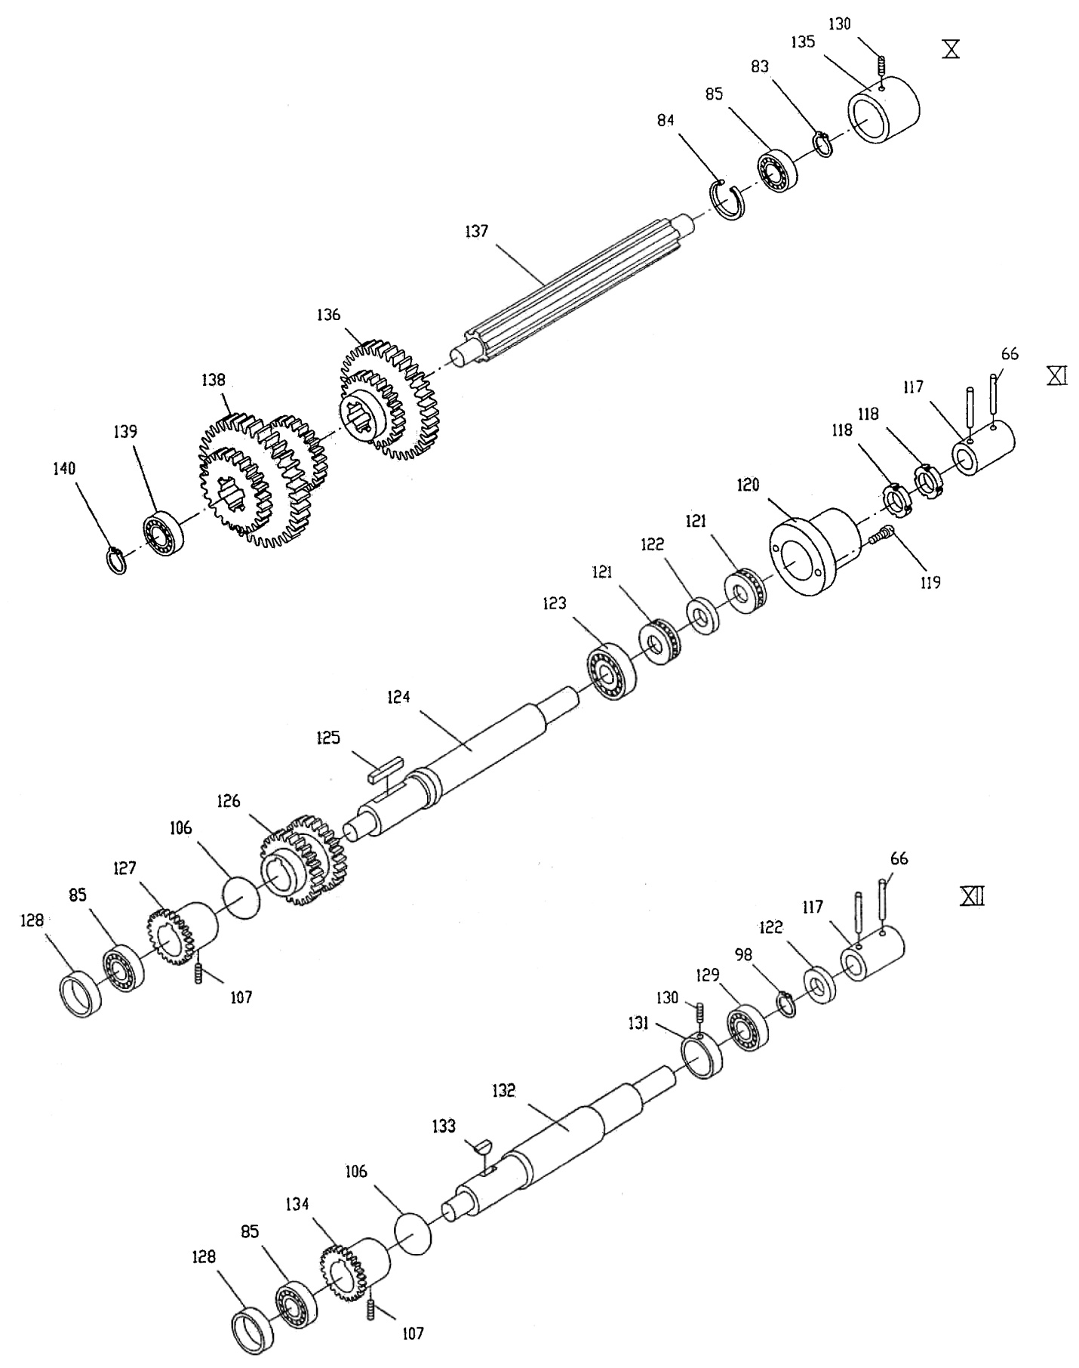

Quick Change Gear Box III – Parts List

Index No. Part No. Description Size Qty

66 ZX-Q66 Taper Pin 5x35 mm 6

83 ZX-Q83 C-Clip 20 mm 3

84 ZX-Q84 C-Clip 42 mm 5

85 BB104 Single Row Radial Ball Bearing 20x42x12 5

98 ZX-Q98 C-Clip 25 mm 3

106 ZX-Q106 Iron Wire 1x160 mm 3

107 TS-1524031 Set Screw M8x12 3

117 ZX-05113C Shaft Coupling 2

118 ZX-Q118 Round Nut M24x1.5 2

119 TS-1503021 Hex Socket Cap Screw M6x10 2

120 ZX-05114C Cover 1

121 BB-51105 Thrust Bearing 25x42x11 2

122 ZX-Q122 Spacer 25 mm 2

123 BB-6305 Ball Bearing 25x62x17 1

124 ZX-05725 Shaft 1

125 ZX-Q125 Key 8x7x50 mm 1

126 ZX-05724 Double Gear 2.25m35T/2.25m36T 1

127 ZX-05723 Gear 2.5m36T 1

128 ZX-05107 Sleeve 2

129 BB-6005 Ball Bearing 25x47x12 1

130 TS-1525021 Set Screw M10x12 2

131 ZX-05103 Bearing Support 1

132 ZX-05701 Shaft 1

133 ZX-Q133 Half Circle Key 6x22 1

134 ZX-05703 Gear 2.5m36T 1

135 TNMP-05102A Bearing Support 1

136 ZX-05702 Double Gear 2.5m24T/2.25m35T 1

137 ZX-05708 Shaft 1

138 ZX-05706 Triple Gear 2m39T/2m52T/2m26T 1

139 BB-6203 Ball Bearing 17x40x12 1

140 ZX-Q140 C-Clip 17 mm 1

Apron Assembly I

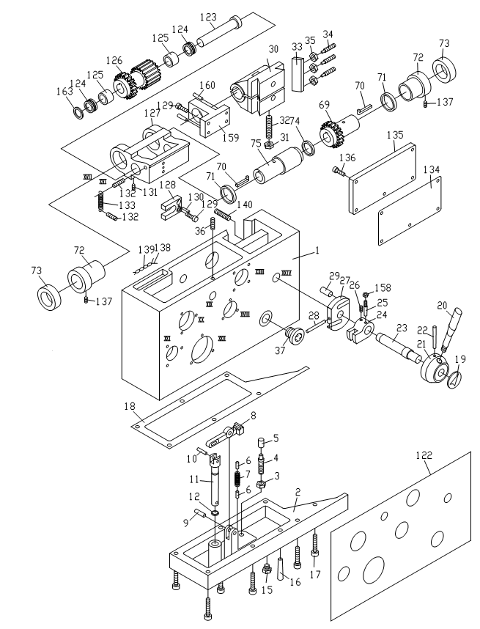

Apron Assembly I – Parts List

Index No. Part No. Description Size Qty

1 TL06101 Apron Casting 1

2 TL06103 Bottom Cover 1

3 TS-1540072 Hex Nut M10 1

4 ZX-A04 Flat Head Set Screw M10x70 1

5 TL06502 Cushion Cap 1

6 ZX-A06 Pin 6n6x16 2

7 ZX-A07 Tensile Spring YI1.2x9x50 1

8 TL06734 Lever 1

9 ZX-A9 Pin 8n6x30 1

10 ZX-A10 Pin 6n6x18 1

11 TL06701-A Pushing Rod 1

12 ZX-A12 Oil Seal 15x2.4 1

15 GB70 Hex Socket Cap Screw M8×6 1

16 ZX-B34 Taper Pin 5x30 2

17 TS-1504041 Hex Socket Cap Screw M8x20 6

18 TL06501 Gasket 1

19 TL06307 Sign Plate 1

20 TL06716 Lever 1

21 ZX-06122 Lever Support 1

22 ZX-B27 Taper Pin 6x60 1

23 TL06717 Half Nut Shaft 1

24 TL06111 Positioning Block 1

25 ZX-A25 Thread Tail Taper Pin 6x25 1

26 TS-1523031 Set Screw M6x10 1

27 ZX-06733 Half Nut Control Plate 1

28 ZX-A28 Taper Pin 6x55 1

29 ZX-06732 Pin 2

30 ZX-06302N New Half Nut 1

31 TS-1540072 Hex Nut M10 1

32 ZX-A32 Cylindrical End Set Screw M10x60 1

33 ZX-06121 Gib 1

34 ZX-06731 Cylindrical End Set Screw 3

35 TS-1540061 Hex Nut M8 3

36 ZX-A36 Set Screw M8x32 1

37 ZX-A37 Oil Sight Glass 20 1

69 TL06727N New Gear 2m25T 1

70 TL06728 Sliding Key 2

71 TL06121N New Spacer 2

72 TL06304N New Positioning Sleeve 2

73 ZX-A73 Ring Seal For Rotating 3x55 2

74 ZX-A74 Oil Seal 35x3.1 1

75 TL06729N New Sleeve 1

122 C6140ZK-06302J Sign Plate 1

123 TL06730 Shaft 1

124 BB-51104 Thrust Bearing 2

125 TL06305 Sleeve 2

126 TL06726N New Worm 1

127 TL06122N New Worm Support 1

128 TL06720 Control Plate 1

129 TS-1514031 Hex Socket Cap Screw M6x20 4

130 ZX-A130 Taper Pin 4x20 1

131 TS-1524031 Set Screw M8x12 2

132 ZX-A132 Screw M8x25 2

133 ZX-A133 Cylindrical Tensile Spring LI-1.6x10x58 1

#### Index Part

#### No. No. Description Size Qty.

134 TL06503 Gasket 1

135 TL06114 Back Cover 1

136 TS-1514011 Hex Socket Cap Screw M6x12 5

137 ZX-A137 Set Screw M8x30 2

138 ZX-A138 Iron Wire 1x50 2

139 ZX-A139 Oil Conducting Cord 3x100 2

140 ZX-A140 Screw M10x40 1

158 TS-1540041 Hex Nut M6 1

159 TL06124 Bracket 1

160 ZX-A160 Taper Pin 5x25 2

163 TL06120 Sleeve 1

Apron Assembly II



Apron Assembly II – Parts List

Index No. Part No. Description Size Qty

38 ZXB23 C-Clip 20 1

39 BB6204 Ball Bearing 20x47x14 1

40 TL06705 Gear 2m65T 1

41 ZXA41 Taper Pin 6x40 1

42 ZXC40 C-Clip 25 1

43 ZX06127N New Bearing Support 1

44 TS1504041 Hex Socket Cap Screw M8x18 3

45 BB6205Z Ball Bearing 25x52x15 1

46 ZXA46 C-Clip 52 1

47 TL06704N New Shaft 2m14T 1

48 TL06706 Hand Wheel Shaft 2mx15T 1

49 ZXH10 Half Circle Key 4x16 1

50 ZXA50 Oil Cup 8 1

51 TL06104 Lever Support 1

52 TS1514031 Hex Socket Cap Screw M6x18 3

53 TL06105 Dial Support 1

54 ZXA54 Cross Head Screw M5x12 3

55 TL06732 Dial 1

56 TL06107 Hand Wheel 1

57 ZX06710 Shaft Driven Lever 1

58 TL06709 Shaft Cover 1

59 ZXA54 Cross Head Screw M5x12 1

60 TL06708 Screw 1

61 TL06707 Pin 1

62 TL06112 End Cover 1

63 TS1514011 Hex Socket Cap Screw M6x12 3

64 TL06733 T Shaped Flat Key 1

65 TL06115 Flange Sleeve 1

66 TS1514011 Hex Socket Cap Screw M6x12 3

67 ZXA67 Flat End Set Screw M6x30 1

68 TS1540041 Hex Nut M6 1

76 TL06109 Flange 1

77 TS1514011 Hex Socket Cap Screw M6x12 3

78 TL06303 Sign Plate 1

79 TL06714 Adjusting Screw 1

80 ZXA80 Oil Seal 8x1.9 1

81 BB7203 Ball Bearing 17x40x12 1

82 TL06713 Shaft 1

83 TL06715 Adjusting Rod 1

84 ZXH10 Half Circle Key 4x16 1

85 TL06712 Spring Cover 1

86 ZXA86 Spring YI-4x32x40 1

87 TL06718 Gear 2m28T 1

88 TL06113 Helical Gear 2.5m40T 1

89 BB7006/P6 Ball Bearing 30x55x13 1

90 TS1523031 Set Screw M6x10 1

91 ZXA25 Thread Tail Taper Pin 6x25 1

92 TL06110 Fork 1

93 ZX06721E Control Rod 1

94 ZX06116E Lever Support 1

95 ZXA95E Cross Head Screw M6x30 1

96 ZXH5 Steel ball 8 1

97 ZXA97 Spring YI-1x7x25 1

98 ZXA98 Flat Head Set Screw M10x16 1

99 ZX06737E Bracket 1

100 ZX06741E Plug 1

101 ZX06739E Gear shaft 1

102 ZXA102E Hex head screw M4x8 1

103 ZXA103E Pin 4x8 1

104 ZXA104 Flat Head Set Screw M4x8 1

105 TL06301 Sleeve 1

106 TL06710 Gear 2m21T/2m57T 1

107 ZXA107 Pin 6n6x8 1

108 TL06711 Shaft 1

109 TL06108 End Cover 1

110 TS1514011 Hex Socket Cap Screw M6x12 3

111 TL06723 Control Shaft 1

112 TL06725 Pin 1

113 TL06724 Control Block 1

114 ZXA114 Oil Seal 20x2.4 1

115 ZXA115 Oil Seal 50x3.1 1

116 TL06119 Lever Flange 1

117 TS1514011 Hex Socket Cap Screw M6x12 3

118 TL06118 Lever Support 1

119 TL06307 Sign Plate 1

120 ZXK06722 Lever 1

121 ZXB27 Taper Pin 6x60 1

164 ZXA164E Hex head screw M6x35 3

165 ZX06738E Rack 1

167 ZX06740E Handle 1

168 ZX06736E Washer 1

169 ZXA169E Hex head screw M5x10 1

170 ZX06303E Label 1

171 ZXA171E Screw M3x5 4

Apron Assembly III (Threading Dial)



Apron Assembly III (Threading Dial) – Parts List

Index No. Part No. Description Size Qty

134 ZX-A141 Half Round Head Screw M6x18 1

135 ZX-11704 Washer 1

136 ZX-11301 Dial 1

137 ZX-11105 Adjusting Washer 1

138 ZX-11701 Shaft 1

139 ZX-H10 Half Circle Key 4x16 mm 1

140 ZX-11703 Adjusting Washer 1

141 ZX-11101 Casting 1

142 ZX-11102E Helical Gear 2m15T 1

143 TS-1550071 Flat Washer M10 1

144 TS-1540072 Hex Nut M10 1

145 ZX-11303 Positioning Sign Plate 1

146 ZX-A147 Half Round Head Screw M3x6 6

147 ZX-11702 Bolt 1

148 ZX-A157 Oil Cup 8 mm 2

149 ZX-A151 Acorn Nut M12 1

150 ZX-11304 Thread Chasing Label 1

Saddle and Cross Slide Assembly



Saddle and Cross Slide Assembly – Parts List

Index No. Part No. Description Size Qty

1 C6136ZK-04101 Saddle Casting 1

2 GB1155-10 Oil Cup 10 mm 7

3 C6136ZK-04501 Wipe Plate 1

4 C6136ZK-04502 Wipe Plate 1

5 ZX-H211 Countersunk Head Screw M5x16 11

6 ZX-04113 Lining Plate 2

7 ZX-04724 Clamping Block 2

8 TS-1505031 Hex Socket Cap Screw M10x25 4

9 ZK-1609 Square Set Screw M8x18 4

10 TS-1540061 Hex Nut M8 4

11 C6136ZK-04503 Wipe Plate 1

12 C6136ZK-04504 Wipe Plate 1

13 J22-10 Square Cap Bolt M12x60 1

14 ZK-1614 Taper Pin 8x45 mm 2

15 TS-1505071 Hex Socket Cap Screw M10x45 8

16 ZX-04729 Clamping Block 1

17 ZX-04730 Locking Plate 1

18 GB119-4n6x10 Pin 4n6x10 1

19 C6136-04716 Chip Guard 1

20 ZX-04740 Clamping Block 1

21 C6136-04738 Positioning Pin 1

22 ZX-04301 Oil Indicator Cap 1

23 ZX-04750 Oil Cap 1

24 ZX-04721 Lever 1

25 ZX-04720 Handle 1

26 GB117-4x25 Taper Pin 4x25 mm 1

27 ZX-CA42 Round Nut M12x1.25 2

28 ZX-04719 Lining 1

29 ZX-04108 Flat Pan 1

31 ZX-04717G Dial 1

32 BB-51102 Thrust Bearing 15x28x9 mm 2

33 ZX-04111 Sleeve 1

34 CL6140ZK-04101J Screw Support 1

35 TS-1490041 Hex Cap Screw M8x25 2

36 ZX-CA53 Oil Cup 8 mm 1

37 C6140ZK-04702 Gear Sliding Sleeve 2m16T 1

38 ZX-H10 Half Circle Key 4x16 mm 1

39 ZX-04751 Flat Key 1

40 C6140ZK-04703(m) Lead Screw 1

41 ZX-04302A Nut Assembly 1

42 ZX-04748 Wedge 1

43 C6136-04502A Wipe Plate 2

44 ZX-04725C Screw 1

45 C6136ZK-04703 Cross Slide Gib 1

46 C6136ZK-04102 Cross Slide 1

47 ZX-04304 Pressing Pin 1

48 KLS1740-04746 Screw 1

49 TS-1540081 Hex Nut M12 2

50 ZX-04714 Screw 2

51 ZX-04732 Pin 1

52 ZX-04709 Sleeve 1

53 TS-1504051 Hex Socket Cap Screw M8x22 3

54 BB-51101 Thrust Bearing 12x26x9 2

55 ZX-04116 Bracket 1

56 ZX-CA64 Taper Pin 8x30 mm 2

57 TS-1491041 Hex Cap Screw M10x30 2

58 ZX-CA62 Oil Cup 6 mm 1

59 ZX-CA42 Round Nut M12x1.25 2

60 ZX-04789 Screw 1

61 ZX-04790 Pushing Rod 1

62 ZX-04788 Stop Pin 1

63 ZX-04507 Stop Pin Cap 1

64 C6140ZK-04769J Sleeve 1

65 ZX-04770 Dish Spring 1

ZX-CSNA Crossfeed Screw & Nut Assy. (index #40-42) 1

ZX-CDA Crossfeed Dial Assembly (index # 27-40,65,65) 1

66 ZX-SC66 Turcite-B (not shown) 510x50x0.8 1

67 ZX-SC67 Turcite-B (not shown) 510x25x0.8 2

Tool Post and Compound Rest



Tool Post and Compound Rest – Parts List

Index No. Part No. Description Size Qty

1 ZX-04103B Revolving Plate 1

2 ZX-04725 Screw 1

3 C6136-04710 Gib 1

4 ZX-04786 Screw 1

5 ZX-04303 Pressing Block 1

6 ZX-04706 Lead Screw 1

7 ZX-04106A Nut 1

8 ZX-04107B Top Slide 1

9 ZX-04501 Wipe Plate 1

10 ZX-F10 Half Circle Key 3x13 mm 1

11 BB-51102 Thrust Bearing 15x28x9 2

12 ZX-04115 Bearing Support 1

13 GB65 Slotted Cheese Head Screw M4x12 3

14 ZX-F14 Taper Pin 3x18 mm 2

15 ZX-04727 Dial 1

16 ZX-04114 Sleeve 1

17 ZX-04768 Dish Spring 1

18 ZX-04767 Sleeve 1

19 ZX-04726 Handle 1

20 ZX-04771 Lining 1

21 ZX-04763 Spring 0.8x6x25 1

22 ZX-04787 Positioning Block 1

23 ZX-04752A T-Slot Nut 1

24 ZX-04754 Shaft 1

25 ZX-04759 Adjusting Lining Sheet 1

26 ZX-04110 Lever Support 1

27 ZX-04753 Handle 1

28 ZX-Q66 Taper Pin 5x35 mm 1

29 ZX-04713B Tool Post 1

30 ZX-F30A Clamping Screw M12x45 8

31 ZX-F31 Oil Cup 8 mm 1

32 ZX-H211 Countersunk Head Screw M5x16 3

33 ZX-04725C Screw 1

34 ZX-F34 Oil Cup 8 mm 2

35 ZX-F35 Spring 0.7x5x9 2

36 SB-6MM Steel Ball 6 mm 2

37 ZX-F37 Round Nut M12x1.25 2

38 ZX-CA39 Cross Head Screw M5x16 1

39 KLS1740-04746K Screw Wrench 1

Tailstock Assembly I



Tailstock Assembly I – Parts List

Index No. Part No. Description Size Qty

1 C6136-03702 Handle 1

2 ZX-T36 Taper Pin 6x32 mm 1

3 C6136-03708 Lever Support 1

4 C6136-03709 Bolt 1

5 C6136-03707 Washer 1

6 C6136-03706 Clamping Block 2

7 C6136-03705 Clamping Block 1

8 ZX-CA83 Oil Cup 10 mm 1

9 C6140ZK-03101A Tailstock Casting 1

10 C6136-03704 Lock Handle 1

11 ZX-A28 Taper Pin 6x55 mm 1

12 ZX-03014 Lever Sleeve 1

13 ZX-T42 Pin 10n6x22 1

14 ZX-03714 Eccentric Shaft 1

15 ZX-T06 Slotted Set Screw M8x14 2

16 ZX-T45 Nail 3x8 mm 6

17 C6136ZK-03303 Indicator Plate 1

18 C6136ZK-03301 Sign Plate: Attention 1

19 C6136-03719 Positioning Block 1

23 JS95-1 Morse Center No. 4 1

24 C6136-03701 Center Sleeve 1

25 ZX-03712 Eccentric Shaft 1

26 C6236-03720 Lead Screw 1

27 GB1096-5x35 Key 5x35 mm 1

28 C6236-03102 Nut 1

29 BB-51104 Thrust Ball Bearing 20x35x10 1

30 GB65-M8x22 Slotted Socket Cap Screw M8x22 3

31 C6140ZK-03013 Back Cover 1

32 ZX-T56 Oil Cup 8 mm 1

33 TS-1504031 Hex Socket Cap Screw M8x18 4

34 C6140ZK-03710J Dial 1

35 C6136-03713 Sleeve 1

36 C6136-03711 Leaf Spring 1

37 C6136-06108 Handwheel 1

38 C6136-06710 Lever 1

39 TS-155010 Plain Washer B16 1

40 TS-2310162 Hex Nut M16 1

41 ZX-T51 Acorn Nut M16 1

Tailstock Assembly II



Tailstock Assembly II – Parts List

Index No. Part No. Description Size Qty

42 C6140ZK-03107A Sliding Base 1

43 GB70-8x80 Hex Socket Cap Screw M8x80 2

44 C6136-03105 Nut 1

45 C6136ZK-03302 Scale Plate 1

47 C6136-03717 Gib 1

48 ZX-03718C Adjusting Screw 2

49 TS-1491121 Hex Cap Screw M10x70 2

50 TS-1550071 Flat Washer 10 mm 2

51 1660R-03705 Pulling Rod 2

52 C6136-03106 Clamping Bracket 1

53 ZX-T28 Taper Washer 16 mm 2

54 ZX-T29 Spherical Washer 16 mm 2

55 TS-2310162 Hex Nut M16 2

Steady Rest Assembly



Steady Rest Assembly – Parts List

Index No. Part No. Description Size Qty

ZK-SRA16 Steady Rest Assembly 16” (index #1-17) 1

1 KLS1740-10703 Screw 3

2 KLS1740-10707 Sliding Sleeve 3

3 KLS1740-10301 Pushing Block 3

4 GB75-6x10 Slotted Set Screw M6x10 6

5 KLS1740-10705 Lever 3

6 KLS1740-10706 Locking Screw 3

7 ZX-C36 Pin 10n6x40 1

8 KLS1740-10701 Hinge Screw 1

9 ZX-SR9 Pin 8n6x40 1

10 ZX-SR10 Hex Nut M20 1

11 ZX-SR11 Flat Washer 20 mm 1

12 KLS1740-10708B Tightening Screw 1

13 KLS1740-10103D Clamping Plate 1

14 KLS1740-10101B Lower Part of Steady Rest 1

15 KLS1740-10102AS Upper Part of Steady Rest 1

16 KLS1740-10702 Round Nut M10 1

17 TS-1550071 Flat Washer 10 mm 1

Follow Rest Assembly



Follow Rest Assembly – Parts List

Index No. Part No. Description Size Qty

ZK-FRA16 Follow Rest Assembly (index #1-9) 1

1 KLS-1740-10710 Screw 2

2 KLS-1740-10704 Nut 2

3 KLS-1740-10709 Sliding Sleeve 2

4 KLS-1740-10301 Supporting Piece 2

5 ZX-SR05 Slotted Set Screw M6x10 4

6 KLS-1740-10706 Locking Screw 2

7 KLS-1740-10705 Handle 2

8 ZX-FR8 Hex Cap Screw M12x55 2

9 KLS-1740-10104B Follow Rest Casting 1

Coolant and Work Light Assembly



Coolant and Work Light Assembly – Parts List

Index No. Part No. Description Size Qty

1 ZK-CW02 Rubber Tube ID 1/2" x 1780 1

2 TS-1481061 Hex Cap Screw M5x25 4

3 TS1540031 Hex Nut M5 4

4 ZX-CW04E Coolant Pump 1

5 TS-154041 Hex Nut M6 2

6 ZX-01727 Clip for Rubber Tube 2

7 ZX-CW07 Cross Head Screw M6x16 2

8 ZX-01728 Fitting 1

9 ZX-01729 Flow Pipe 1

10 ZK-CW10 Coolant Device 1

ZK-CW10-1 Coolant Tap G 3/8” 1

11 TS-1514021 Hex Socket Cap Screw M6x16 2

12 TS-1515051 Hex Socket Cap Screw M8x40 2

13 18101 Lamp Support 1

14 ZX-S04 Screw M6x14 4

15 ZX-CW15 Lamp Frame 1

Bulb 50W,AC24V 1

Light Assembly 1

Toolbox, Accessories, and Attachments

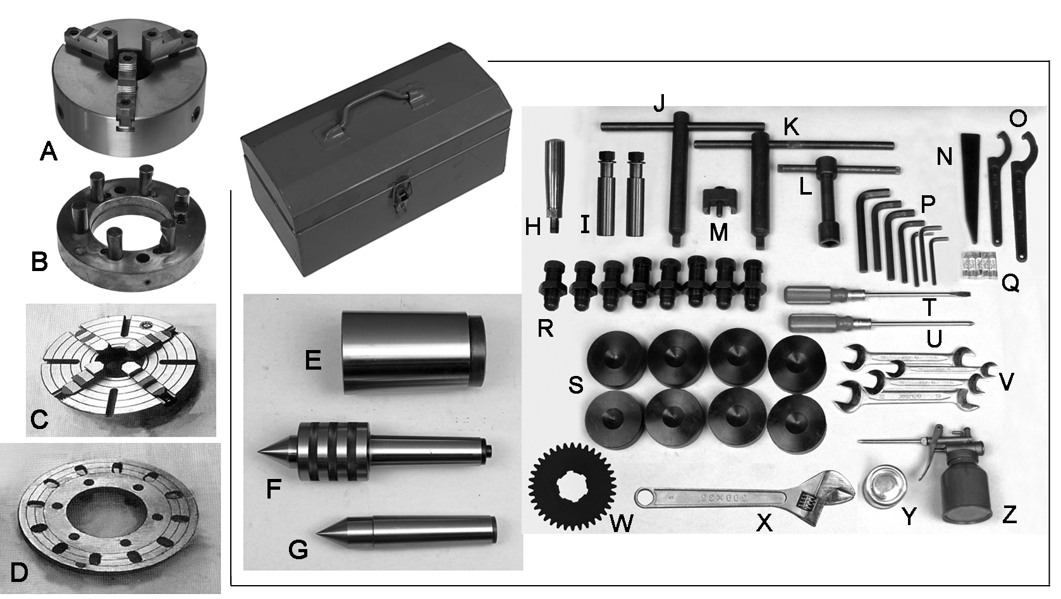

Index No. Part No. Description Size Qty

A ZK-2401 3-Jaw Scroll Chuck 200mm, D1-6 1

B ZK-2402 Drive Plate 200mm 1

C ZK-2403 4-Jaw Independent Chuck 250mm, D1-6 1

D ZK-2404 Face Plate 400mm 1

E ZK-2405 Morse Reduction Sleeve * MT6/4 1

F ZK-2406 Live Center * MT4 1

G ZK-2407 Dead Center * MT4 1

H ZX-04721 Crossfeed Handle 1

I ZK-2409 Shear Pin 2

J ZK-2410 Cam Wrench * 1

K ZK-2411 Chuck Wrench * 1

L ZK-2412 Tool Post Wrench * 1

M ZK-2413 Gap Bridge Pin Driver * 1

N ZK-2414 Drift Key * 1

O RNS-100/110 Round Nut Spanner * 100-110 1

RNS-115/130 Round Nut Spanner * 115-130 1

P Hex Key Set * 2,2.5,3,4,5,6,8,10 mm 1

Q ZK-FU1 Fuse 2A 3

ZK-FU2 Fuse 3A 2

R ZK-2420 Leveling Bolt * 8

ZK-2421 Hex Nut * 8

S ZK-2422 Leveling Pad 8

T ZX-OP-14 Flat Blade Screw Driver * 1

U ZX-OP-15 Cross Point Screw Driver * 1

V Open End Wrench Set *……………....10-12,9-11,12-14,17-19 mm 1

W TNMP08501A Gear * 3.5m35T 1

X Adjustable Wrench * 1

Y ZX-OP-10 Touchup Paint Can (JET White) * 1

Z ZX-OP-09 Oil Gun * 1

ZK-TBC Tool Box Complete, ZK Lathes *(includes items with asterisk * )*

Electrical Components – Parts List

(Index numbers are shown below; diagram numbers are shown on following page.)

Index No. Diagram No. Part No. Description Size Qty

1......... HL ZX-HL Power Indicator Light AD11-30/20 1

2 SA2 ZK-SA2 Coolant Pump Switch ZB2-BZ101C 1

3 SB2 ZK-SB2 Jog Button XB2-ZA131 1

4 SB1 ZK-SB1 Emergency Stop Button ZB2-BZ102C 1

5 SA1 ZK-SA1 Commutator Switch LW5D-16 1

6 QF ZK-QF Master Switch (40A) DZ15-40 1

7 FU1 ZK-FU1 Fuse (2A) RT18-32 3

8 FU2 ZK-FU2 Fuse (3A) RT18-32 1

9 FU3 ZK-FU3 Fuse (3A) RT18-32 1

10 FU4 ZK-FU4 Fuse (3A) RT18-32 1

12 KM3 ZK-KM3 A.C. Contactor 3TB40 1

13 KA ZK-KA A.C. Contactor 3TH80 1

14 KM2 ZK-KM2 A.C. Contactor 3TB42 1

15 KM1 ZK-KM1 A.C. Contactor 3TB42 1

16 XB ZK-XB Copper Plate (for grounding) 1

17 XT1 ZK-XT1 Wiring Board JF5 1

18 XT2 ZK-XT2 Wiring Board JF5 1

19 TC ZK-TC Control Transformer JBK5-160-TH 1

20 SQ1 ZK-SQ1 Limit Switch JW2A-11H/W1 1

21 SQ2 ZK-SQ2 Limit Switch TM1306 1

22 SQ3 ZK-SQ3 Limit Switch TM1306 1

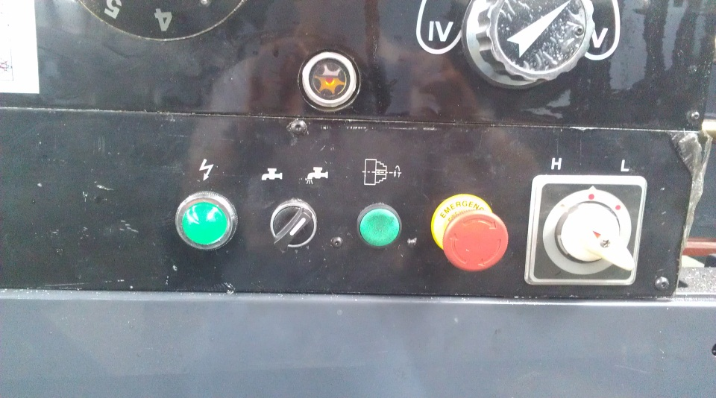

6 1 2 3 4 7-10 5 13 12

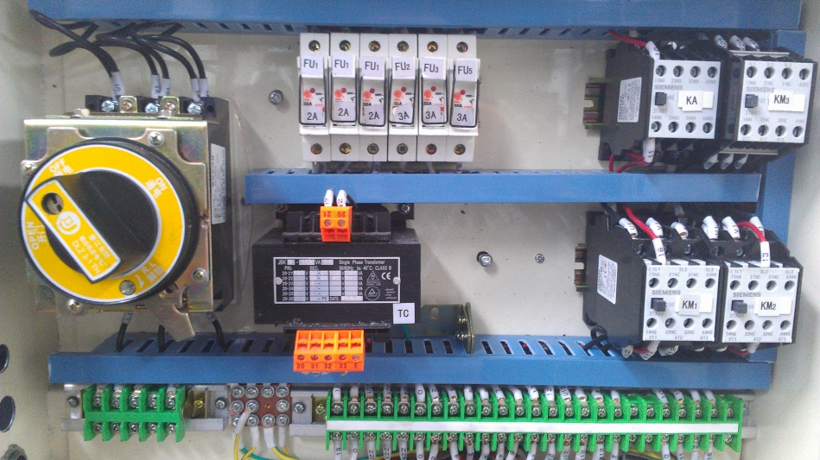

17 16 19 18 15 14

Electrical Diagram



Rotary Switch Diagram

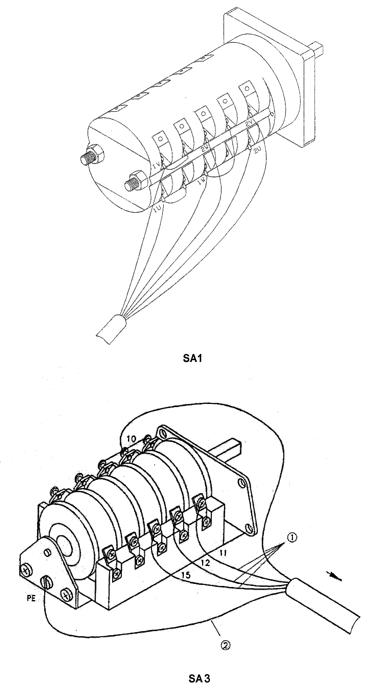

###### Safety guard cover

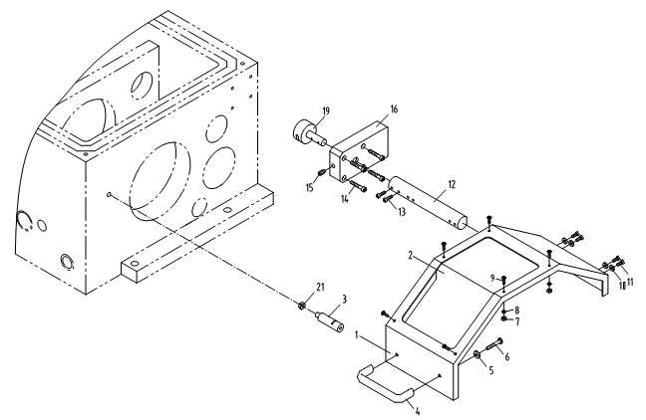

#### Index Part

#### No. No. Description Size Qty.

1 ZX19701E Protection guard 1

2 ZX19501E Protection guard visual glass 1

3 ZX19704E Fixing rod 1

4 ZXS04E Handle Z96-6 1

5 ZXS05E Plain washers 6 2

6 ZXS06E Cross recessed pan head screws M6x12 2

7 ZXS07E Hexagon thin nuts M4 6

8 ZXS08E Plain washers 4 6

9 ZXS09E Cross recessed pan head screws M4x12 6

10 ZXS10E Plain washers 5 4

11 ZXS11E Hexagon socket cap head screws M5x16 4

12 ZX19703E Rest bar 1

13 ZXS13E Slotted set screws M8x10 2

14 ZXS14E Hexagon socket cap head screws M6x35 4

15 ZXS15E Hexagon socket set screws M8x16 1

16 GH1440A19101E Switch box 1

19 ZX19702E Shaft 1

21 ZXS21E Nut M8 1